CREATE TABLE Bus (

bus_id INT,

bus_name VARCHAR(255),

bus_type TEXT,

bus_number INT,

totalseats INT,

aviableseats INT,

PRIMARY KEY(bus_id)

);

CREATE TABLE BusType( bustype_id decimal(12), bus_name varchar(50), bus_id INT,

PRIMARY KEY (bustype_id),

FOREIGN KEY (bus_id) REFERENCES Bus (bus_id)

);

CREATE TABLE Location(

loc_id decimal(12),

loc_name varchar(50),

user_id INT,

PRIMARY KEY(loc_name),

FOREIGN KEY(user_id) REFERENCES Users(user_id)

);

CREATE TABLE timetable (

time_id decimal(12),

firstloct_name varchar(50),

lastloct_name varchar(50),

day TEXT NOT NULL,

platform_id decimal(12),

bus_id INT,

PRIMARY KEY(time_id),

FOREIGN KEY(bus_id) REFERENCES bus(bus_id)

);

CREATE TABLE Users (

user_id INT,

user_name VARCHAR(255),

password TEXT,

repassword TEXT,

PRIMARY KEY(user_id)

);

CREATE TABLE distance(

dist_id INT,

bus_name VARCHAR(255),

loc_name tEXT,

dist VARCHAR(12),

bus_id int,

primary key(dist_id),

foreign key(loc_name) REFERENCES location(loc_name),

foreign key(bus_id) REFERENCES bus(bus_id)

);

CREATE TABLE city(

city_id decimal(12),

city_name VARCHAR(255),

bus_id int,

bus_type text,

Primary key(city_id),

Foreign key(bus_id) REFERENCES Bus(bus_id)

);

CREATE TABLE Fare(

fare_id INT,

fare VARCHAR(12),

bustype_id DECIMAL(12),

bus_type VARCHAR(50),

Primary key(fare_id),

foreign key(bustype_id) references BusType(bustype_id)

);

CREATE TABLE bus_stops(

st_id INT,

stop_num DECIMAL(12),

bus_id INT,

bus_name VARCHAR(255),

PRimary KEY(st_id),

FOREIGN KEY(bus_id) REFERENCES Bus(bus_id)

);

CREATE TABLE Needed_time(

ntime_id DECIMAL(12),

user_id INT,

departure_t TIME,

arrival_t TIME,

DAY TEXT NOT NULL,

user_name VARCHAR(255),

PRIMARY KEY (ntime_id),

FOREIGN KEY (user_id) REFERENCES Users(user_id)

);

INSERT INTO bus(bus_id, bus_name, bus_type, bus_number, totalseats, availbeseats)

VALUES

(1, 'Busmate', 'Coach','2019','30','5'),

(2, 'Kompan', 'School bus','2023','25','6'),

(3, 'Oneness', 'Shuttle bus','2000','20','10'),

(4, 'KOMBAN', 'Minibus','2001','15','8'),

(5, 'Arifin', 'Minicoach','2002','15','9'),

(6, 'Sevenz', 'Double-decker bus','2018','40','16'),

(7, 'Saho', 'Single-decker bus','2007','20','17'),

(8, 'King', 'Low-floor bus','2003','12','18'),

(9, 'Companion', 'High-floor bus','2004','24','9'),

(10, 'Star tour', 'Trolleybus','2017','35','20'),

(11, 'Zed King', 'Articulated bus','2045','30','14'),

(12, 'Tesorito', 'Gyrobus','2001','25','5'),

(13, 'Humsafar', 'Minibus','2005','12','6'),

(14, 'Daviran', 'Tram','2011','45','30'),

(15, 'Tiger', 'Minibus','2009','15','12'),

(16, 'Watsica', 'Trolleybus','2008','40','27'),

(17, 'Lampland', 'School bus','2015','30','21'),

(18, 'Littel-Bayern', 'Minicoach','2016','10','3'),

(19, 'Mustan', 'Gyrobus','2012','20','4'),

(20, 'Toyoto', 'High-floor bus','2013','35','13');

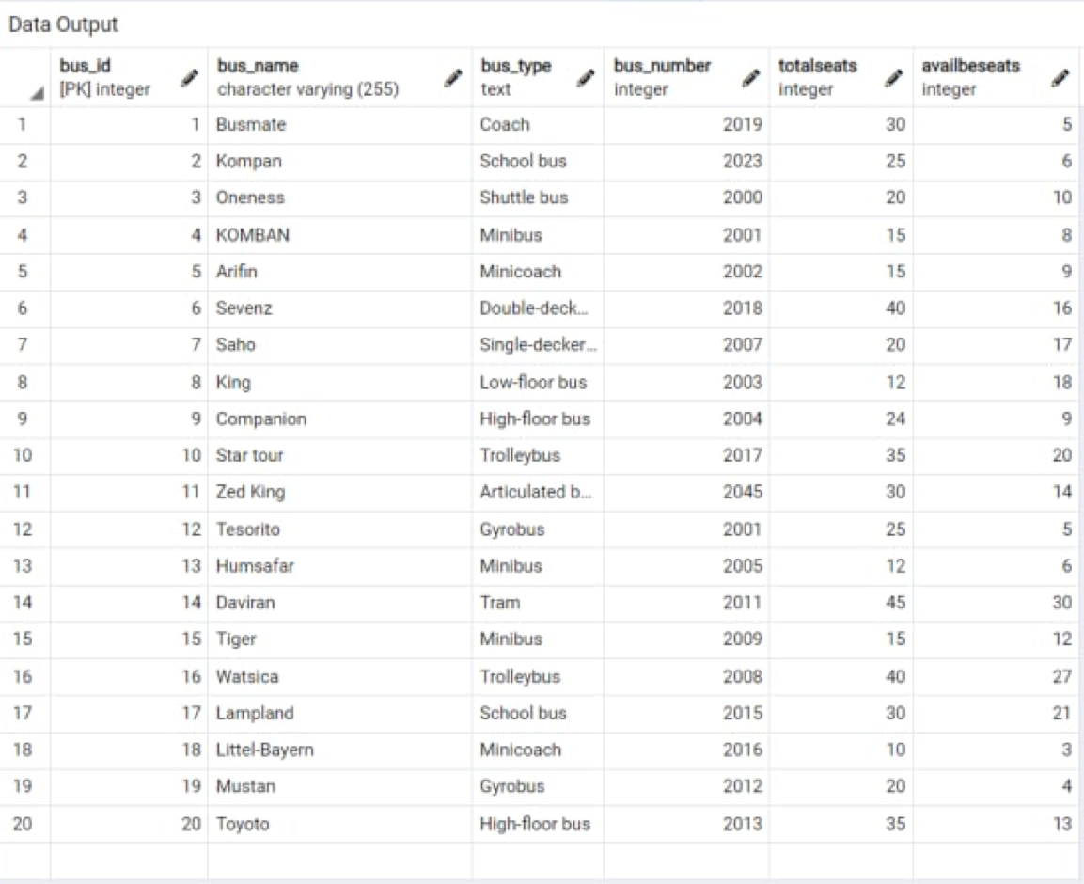

INSERT INTO bustype(bustype_id, bus_name)

VALUES

(1, 'deluxe'),

(2, 'public'),

(3, 'normal'),

(4, 'normal'),

(5, 'deluxe'),

(6, 'public'),

(7, 'public'),

(8, 'deluxe'),

(9, 'normal'),

(10, 'deluxe'),

(11, 'deluxe'),

(12, 'public'),

(13, 'normal'),

(14, 'public'),

(15, 'public'),

(16, 'deluxe'),

(17, 'normal'),

(18, 'public'),

(19, 'deluxe'),

(20, 'normal');

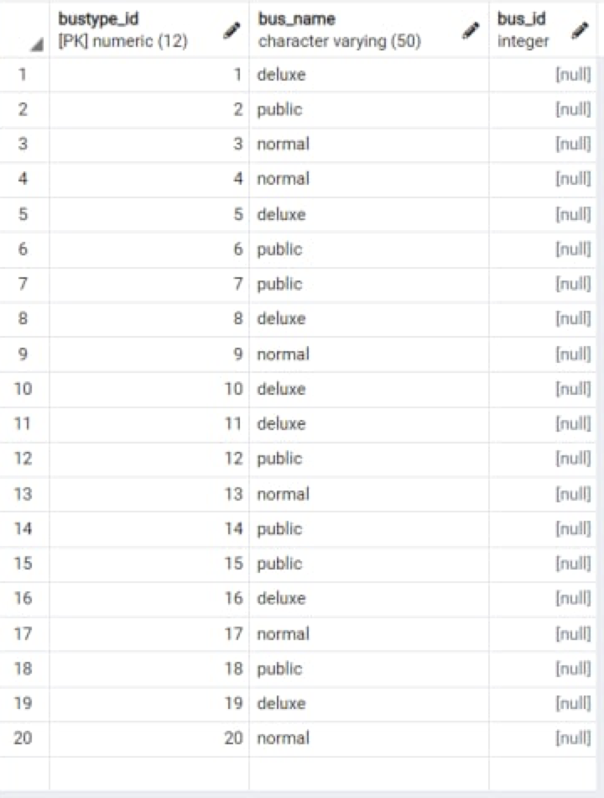

INSERT INTO Users(user_id, user_name,password,repassword)

VALUES

(1, 'Carlyn','cztFFWF','cztFFWF'),

(2, 'Lynnea','3EmnamcJy','3EmnamcJy'),

(3, 'Ericha','YyEin5qCtx','YyEin5qCtx'),

(4, 'Stevana','oiBL1s','oiBL1s'),

(5, 'Ewell','sAp4Qx','sAp4Qx'),

(6, 'Kenyon','hbBFt438','hbBFt438'),

(7, 'Emmeline','m1eMg6','m1eMg6'),

(8, 'Kary','QGgCYLxqY','QGgCYLxqY'),

(9, 'Ambrosi','gzsRB3yEgfmK','gzsRB3yEgfmK'),

(10, 'Jefferson','q7Saqp','q7Saqp'),

(11, 'Zorine','DmzBJZ','DmzBJZ'),

(12, 'Fabio','G0qyEr8H','G0qyEr8H'),

(13, 'Micki','cP6OjQo1hF','cP6OjQo1hF'),

(14, 'Leeland','UN4SQsT','UN4SQsT'),

(15, 'Berry','et3XAPWiwG','et3XAPWiwG'),

(16, 'Albertine','aSHdcBx3H','aSHdcBx3H'),

(17, 'Adena','JKu96I','JKu96I'),

(18, 'Hillyer','3820e9dMI','3820e9dMI'),

(19, 'Shaw','vYKpayKb','vYKpayKb'),

(20, 'Ynes','UnXfcpI9d','UnXfcpI9d');

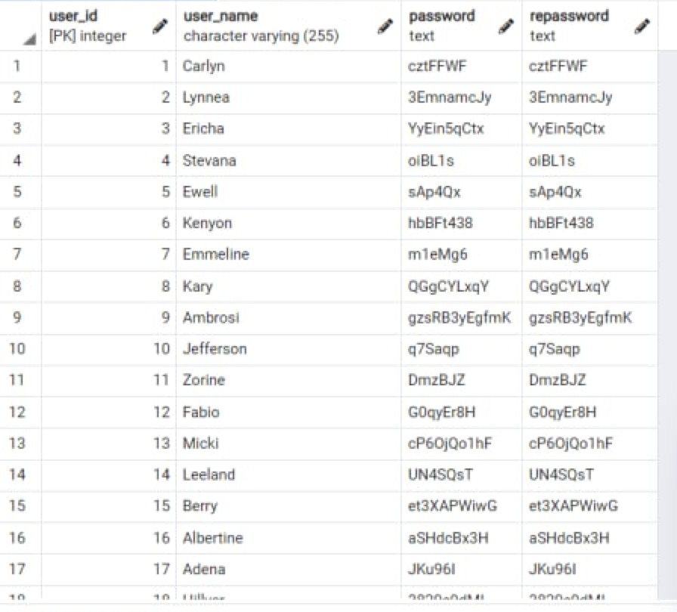

CREATE TABLE timetable (

time_id decimal(12),

firstloct_name varchar(50),

lastloct_name varchar(50),

day TEXT NOT NULL,

platform_id decimal(12),

bus_id INT,

PRIMARY KEY(time_id),

FOREIGN KEY(bus_id) REFERENCES bus(bus_id)

);

INSERT INTO timetable(time_id, firstloct_name,lastloct_name,day,platform_id,bus_id)

VALUES

(1, '8:00 AM','8:00 PM','Monday','11','1'),

(2, '7:00 AM','7:00 PM','Tuesday','12','2'),

(3, '6:00 AM','6:00 PM','Wednsday','13','3'),

(4, '5:00 AM','7:00 PM','Thursday','14','4'),

(5, '7:30 AM','8:00 PM','Friday','15','5'),

(6, '8:20 AM','6:30 PM','Sunday','16','6'),

(7, '6:30 AM','6:30 PM','Saturday','17','7'),

(8, '5:45 AM','7:00 PM','Monday','18','8'),

(9, '6:55 AM','5:55 PM','Tuesday','19','9'),

(10, '7:45 AM','7:45 PM','Wednsday','20','10'),

(11, '8:30 AM','8:00 PM','Thursday','21','11'),

(12, '9:00 AM','8:40 PM','Friday','22','12'),

(13, '9:30 AM','6:00 PM','Sunday','23','13'),

(14, '7:50 AM','6:30 PM','Saturday','24','14'),

(15, '5:50 AM','5:50 PM','Monday','25','15'),

(16, '8:20 AM','4:40 PM','Tuesday','26','16'),

(17, '9:00 AM','8:30 PM','Wednsday','27','17'),

(18, '6:00 AM','4:40 PM','Thurday','28','18'),

(19, '8:45 AM','8:30 AM','Friday','29','19'),

(20, '10:00 AM','7:00 PM','Sunday','30','20');

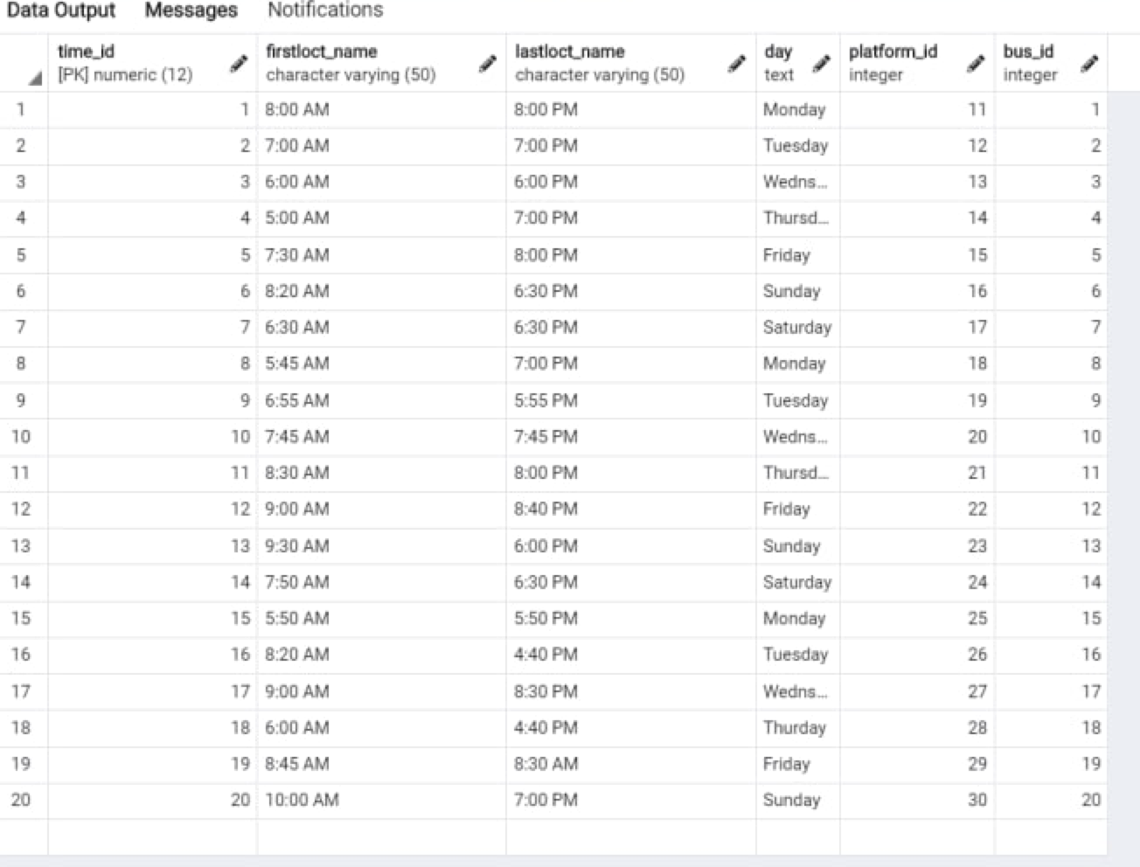

INSERT INTO Needed_time(ntime_id, departure_t, arrival_t, day, user_id, user_name)

VALUES

(1, '6:45 AM', '7:56 PM', 'Monday','1','Sam'),

(2, '7:10 AM', '11:50 PM', 'Sunday','2','Mark'),

(3, '6:45 AM', '3:37 PM', 'Saturday','3','Michel'),

(4, '10:10 AM', '6:00 AM', 'Wednsday','4','Sophi'),

(5, '8:00 AM', '7:00 AM', 'Thursday','5','Edward'),

(6, '9:40 AM', '7:45 PM', 'Saturday','6','Veronica Wynn'),

(7, '11:00 PM', '5:35 PM', 'Tuesday','7','Igor Shields'),

(8, '6:45 AM', '9:00 PM', 'Monday','8','Renesmae Carty'),

(9, '5:55 AM', '11:00 AM', 'Tuesday','9','Clive Gibbons'),

(10, '7:30 AM', '7:40 PM', 'Tuesday','10','Darius Andrews'),

(11, '6:30 AM', '9:35 PM', 'Sunday','11','Meredith'),

(12, '5:00 AM', '5:34 PM', 'Friday','12', 'Trinity Oneill'),

(13, '12:26 AM', '3:58 PM', 'Saturday','13','Eilish Burton'),

(14, '2:49 AM', '6:56 AM', 'Sunday','14','Brandy Daly'),

(15, '2:04 PM', '3:21 PM', 'Monday','15','Daisie Mair'),

(16, '10:02 AM', '2:16 PM', 'Tuesday','16','Hilary Battle'),

(17, '6:21 PM', '5:50 PM', 'Wednesday','17','Victoria Campbell'),

(18, '11:39 PM', '8:20 PM', 'Thursday','18','Stefania Leal'),

(19, '5:16 PM', '2:07 PM', 'Friday', '19','Carwyn Dalton'),

(20, '10:43 AM', '3:07 AM', 'Saturday','20','Archer Love');

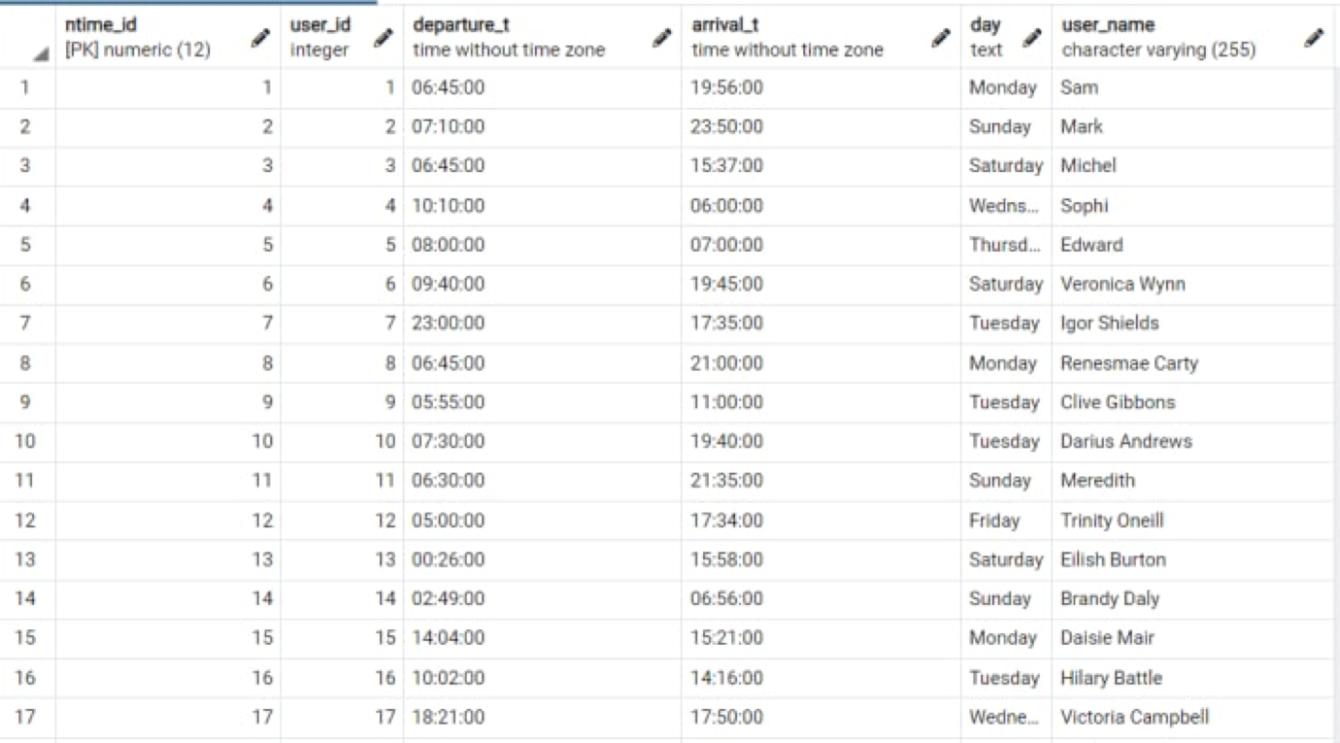

INSERT INTO bus_stops(st_id, stop_num, bus_name, bus_id)

VALUES

(1, '15', 'Busmate', '1'),

(2, '20', 'Kompan', '2'),

(3, '11', 'Oneness', '3'),

(4, '15', 'KOMBAN', '4'),

(5, '30', 'Arifin', '5'),

(6, '45', 'Sevenz', '6'),

(7, '41', 'Saho', '7'),

(8, '32', 'King', '8'),

(9, '27', 'Companion', '9'),

(10, '25', 'Star tour', '10'),

(11, '19', 'Zed King', '11'),

(12, '34', 'Tesorito', '12'),

(13, '60', 'Humsafar', '13'),

(14, '34', 'Daviran', '14'),

(15, '29', 'Tiger', '15'),

(16, '31', 'Watsica', '16'),

(17, '26', 'Lamplant', '17'),

(18, '14', 'Littel-Bayern', '18'),

(19, '50', 'Mustan', '19'),

(20, '51', 'Toyoto', '20');

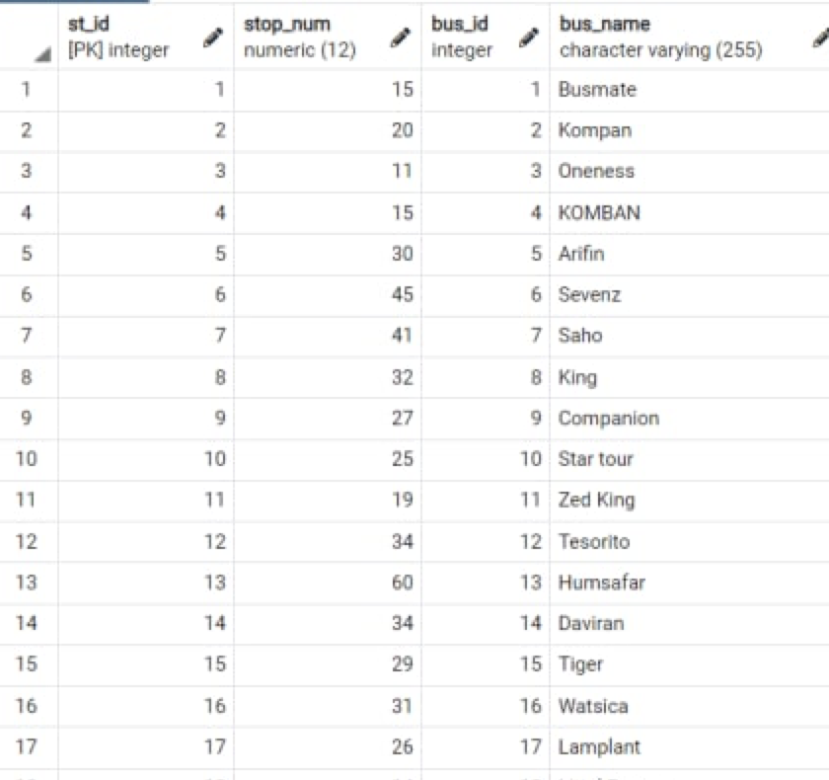

INSERT INTO Fare(fare_id, fare, bus_type, bustype_id )

values

(1,'$1.91', 'deluxe', '1'),

(2,'$2.94', 'public', '2'),

(3,'$2.70', 'normal', '3'),

(4,'$3.02', 'normal', '4'),

(5,'$4.08', 'deluxe', '5'),

(6,'$6.98', 'public', '6'),

(7,'$7.87', 'public', '7'),

(8,'$3.82', 'deluxe', '8'),

(9,'$0.29', 'normal', '9'),

(10,'$8.88', 'deluxe', '10'),

(11,'$6.86', 'deluxe', '11'),

(12,'$8.71', 'public', '12'),

(13,'$3.12', 'normal', '13'),

(14,'$2.61', 'public', '14'),

(15,'$5.06', 'public', '15'),

(16,'$2.12', 'deluxe', '16'),

(17,'$2.30', 'normal', '17'),

(18,'$6.33', 'public', '18'),

(19,'$5.76', 'deluxe', '19'),

(20,'$8.13', 'normal', '20');

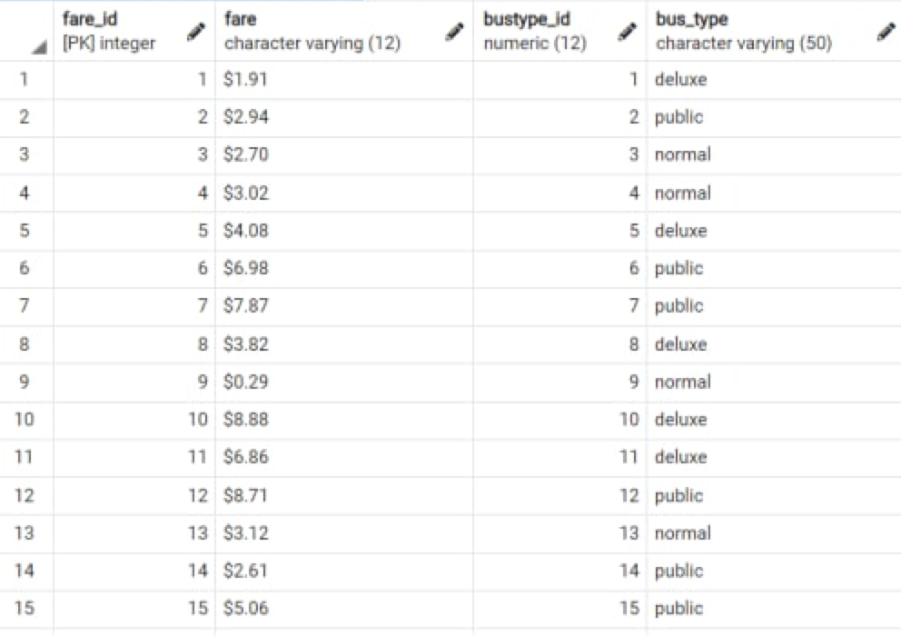

INSERT INTO city(city_id, city_name, bus_id, bus_type)

VALUES

('101', 'Nur-sultan',1, 'Coach'),

('102', 'Almaty', 2, 'School bus'),

('103', 'Semey', 3, 'Shuttle bus'),

('104', 'Karaganda', 4, 'Minibus'),

('105', 'Aktobe', 5, 'Minicoach'),

('106', 'Shymkent', 6, 'Double-decker bus'),

('107', 'New york', 7, 'Single-decker bus'),

('108', 'London', 8, 'Low-floor bus'),

('109', 'Knoxville', 9, 'High-floor bus'),

('110', 'Faiyum', 10, 'Trolleybus'),

('111', 'Nagpur', 11, 'Articulated bus'),

('112', 'Valencia', 12, 'Gyrobus'),

('113', 'Krasnoyarsk', 13, 'Minibus'),

('114', 'BAMAKO', 14, 'Tram'),

('115', 'Málaga', 15, 'Minibus'),

('116', 'Greensboro', 16, 'Trolleybus'),

('117', 'Constanta', 17, 'School bus'),

('118', 'AMSTERDAM', 18, 'Minicoach'),

('119', 'Brno', 19, 'Gyrobus'),

('120', 'Macapá', 20, 'High-floor bus');

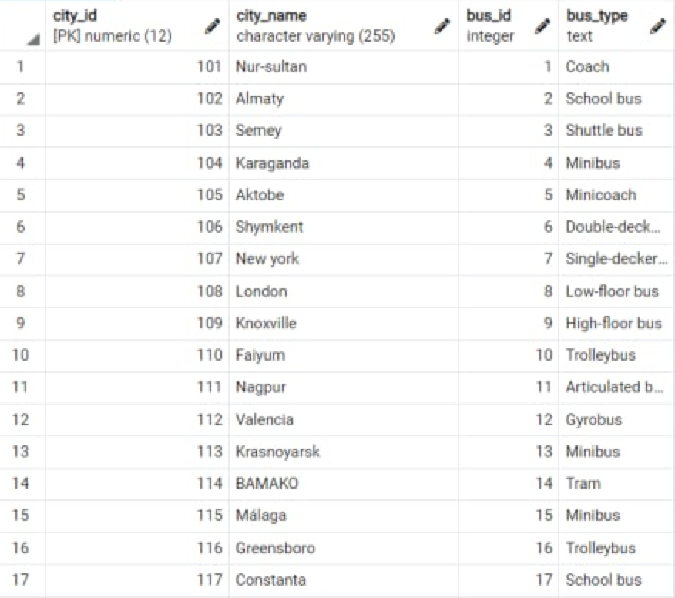

INSERT INTO location(loc_id, loc_name)

VALUES

(1, 'Lantern Lane-George Street'),

(2, 'Main Street West-11th Street'),

(3, 'Front Street South-7th Avenue'),

(4, 'Eagle Street-Forest Avenue'),

(5, 'Park Avenue-Taylor Street'),

(6, 'Catherine Street-Beechwood Drive'),

(7, 'Route 29-Cedar Street'),

(8, '9th Street-Elizabeth Street'),

(9, 'Railroad Street-Magnolia Avenue'),

(10, 'Route 10-14th Street'),

(11, 'Lincoln Avenue-4th Avenue'),

(12, 'Maple Street-Spring Street'),

(13, 'Schoolhouse Lane-York Street'),

(14, 'Locust Lane-Woodland Road'),

(15, 'Meadow Lane-Strawberry Lane'),

(16, 'Carriage Drive-Pennsylvania Avenue'),

(17, 'Cleveland Avenue-Mill Road'),

(18, 'Columbia Street-Grant Street'),

(19, 'Franklin Court-6th Street'),

(20, 'Beech Street-Fairway Drive');

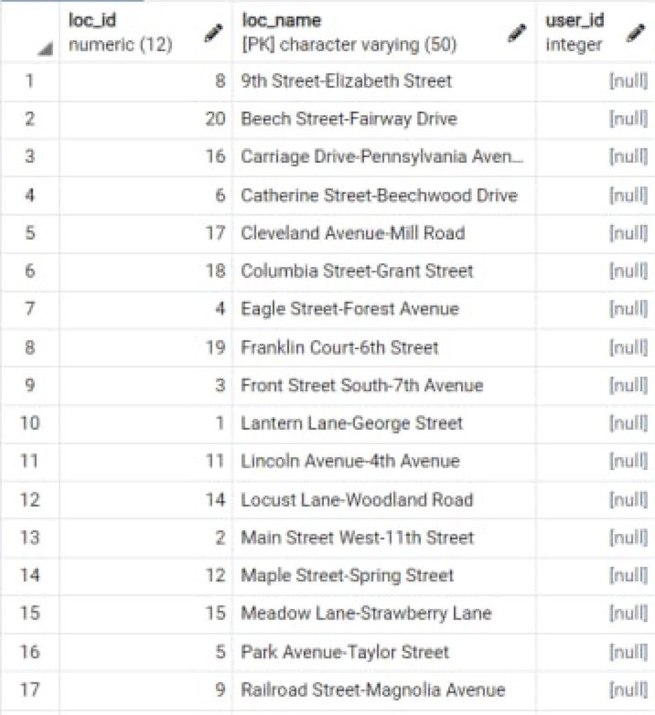

insert into distance(dist_id, bus_name, loc_name, dist)

values

(1, 'Busmate', 'Lantern Lane-George Street', '100km'),

(2, 'Kompan', 'Main Street West-11th Street', '150km'),

(3, 'Oneness', 'Front Street South-7th Avenue', '190km'),

(4, 'KOMBAN', 'Eagle Street-Forest Avenue', '90km'),

(5, 'Arifin', 'Park Avenue-Taylor Street', '15лm'),

(6, 'Sevenz', 'Catherine Street-Beechwood Drive', '350km'),

(7, 'Saho', 'Route 29-Cedar Street', '120km'),

(8, 'King', '9th Street-Elizabeth Street', '180km'),

(9, 'Companion', 'Railroad Street-Magnolia Avenue', '240km'),

(10, 'Star tour', 'Route 10-14th Street', '120km'),

(11, 'Zed king', 'Lincoln Avenue-4th Avenue', '250km'),

(12, 'Tesorito', 'Maple Street-Spring Street', '360km'),

(13, 'Humsafar', 'Schoolhouse Lane-York Street', '100km'),

(14, 'Daviran', 'Locust Lane-Woodland Road', '134km'),

(15, 'Tiger', 'Meadow Lane-Strawberry Lane', '120km'),

(16, 'Watsica', 'Carriage Drive-Pennsylvania Avenue', '110km'),

(17, 'Lampland', 'Cleveland Avenue-Mill Road', '160km'),

(18, 'Littel-Bayern', 'Columbia Street-Grant Street','67km'),

(19, 'Mustan', 'Franklin Court-6th Street', '79km'),

(20, 'Toyoto', 'Beech Street-Fairway Drive', '95km');

